Maven Spring Hibernate 表格一對多新增實作
- 建立Maven Web App
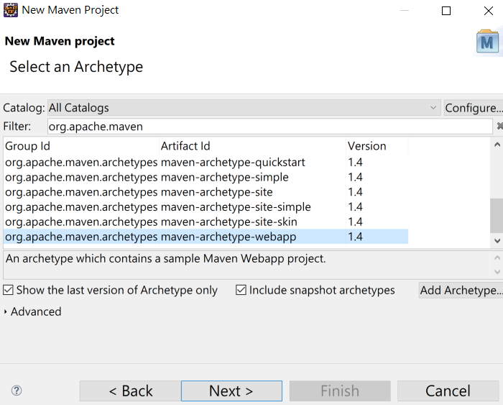
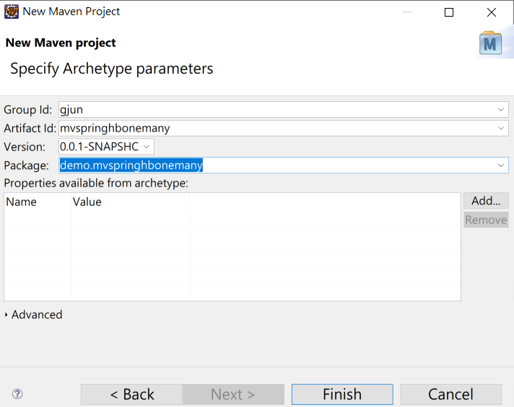
- 修正專案參數
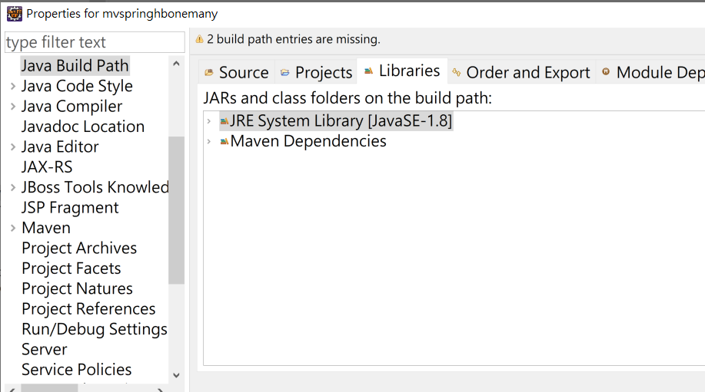
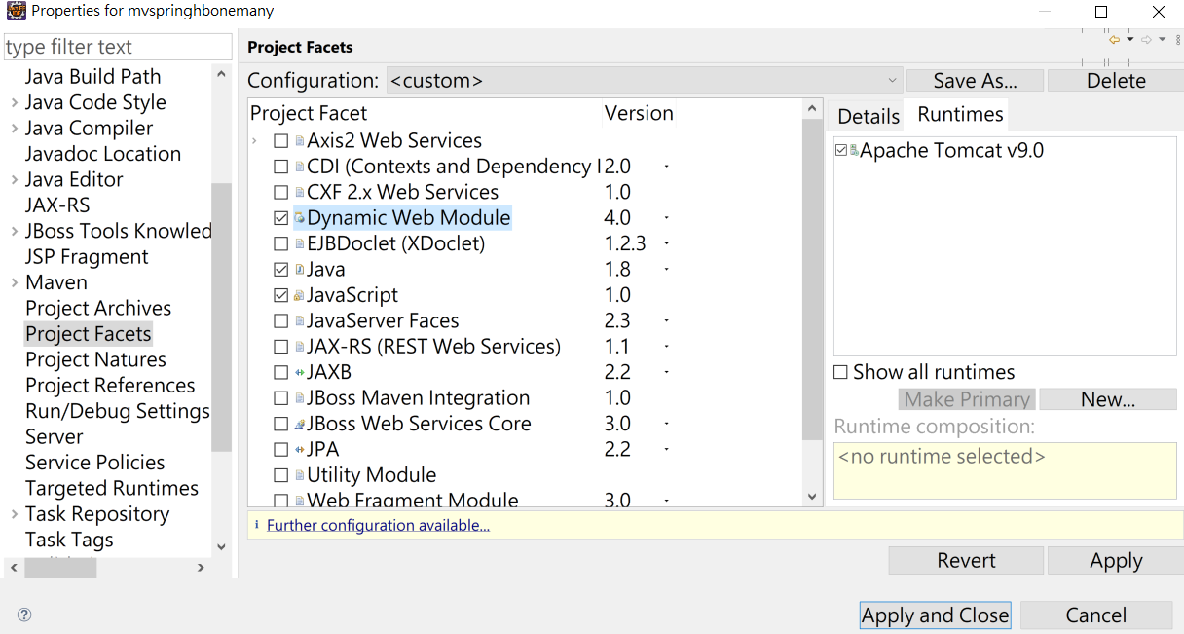
- 修改pom.xml
<dependency>
<groupId>javax.servlet</groupId>
<artifactId>jstl</artifactId>
<version>1.2</version>
</dependency>
<dependency>
<groupId>mysql</groupId>
<artifactId>mysql-connector-java</artifactId>
<version>8.0.22</version>
</dependency>
<dependency>
<groupId>org.springframework</groupId>
<artifactId>spring-webmvc</artifactId>
<version>5.2.17.RELEASE</version>
</dependency>
<dependency>
<groupId>org.hibernate</groupId>
<artifactId>hibernate-core</artifactId>
<version>5.5.7.Final</version>
</dependency>
<dependency>
<groupId>com.google.code.gson</groupId>
<artifactId>gson</artifactId>
<version>2.8.8</version>
</dependency>
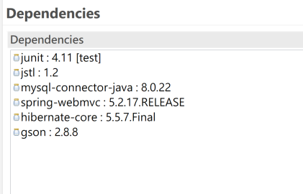
- 加入spring webmvc 環境設定之xml
修改web.xml
<?xml version="1.0" encoding="UTF-8"?>
<web-app xmlns:xsi="http://www.w3.org/2001/XMLSchema-instance"
xmlns="http://xmlns.jcp.org/xml/ns/javaee" xsi:schemaLocation="http://xmlns.jcp.org/xml/ns/javaee http://xmlns.jcp.org/xml/ns/javaee/web-app_4_0.xsd" id="WebApp_ID" version="4.0">
<display-name>mvspringjson</display-name>
<welcome-file-list>
<welcome-file>index.html</welcome-file>
<welcome-file>index.htm</welcome-file>
<welcome-file>index.jsp</welcome-file>
<welcome-file>default.html</welcome-file>
<welcome-file>default.htm</welcome-file>
<welcome-file>default.jsp</welcome-file>
</welcome-file-list>
<servlet>
<servlet-name>dispatcher</servlet-name>
<servlet-class>
org.springframework.web.servlet.DispatcherServlet
</servlet-class>
<load-on-startup>1</load-on-startup>
</servlet>
<servlet-mapping>
<servlet-name> dispatcher </servlet-name>
<url-pattern>/</url-pattern>
</servlet-mapping>
</web-app>

新增 dispatcher-servlet.xml
<?xml version='1.0' encoding='UTF-8' ?>
<beans xmlns="http://www.springframework.org/schema/beans"
xmlns:xsi="http://www.w3.org/2001/XMLSchema-instance"
xmlns:p="http://www.springframework.org/schema/p"
xmlns:aop="http://www.springframework.org/schema/aop"
xmlns:mvc="http://www.springframework.org/schema/mvc"
xmlns:context="http://www.springframework.org/schema/context"
xmlns:tx="http://www.springframework.org/schema/tx"
xsi:schemaLocation="http://www.springframework.org/schema/beans http://www.springframework.org/schema/beans/spring-beans-4.0.xsd
http://www.springframework.org/schema/aop http://www.springframework.org/schema/aop/spring-aop-4.0.xsd
http://www.springframework.org/schema/mvc
http://www.springframework.org/schema/mvc/spring-mvc-4.0.xsd
http://www.springframework.org/schema/context http://www.springframework.org/schema/context/spring-context-4.0.xsd
http://www.springframework.org/schema/tx http://www.springframework.org/schema/tx/spring-tx-4.0.xsd">

<mvc:annotation-driven />
<context:component-scan base-package="demo.controller">
</context:component-scan>
<bean id="viewResolver"
class="org.springframework.web.servlet.view.InternalResourceViewResolver"
p:prefix="/WEB-INF/jsp/"
p:suffix=".jsp" />
</beans>

- 建立一個spring測試程式
package demo.controller;

import org.springframework.stereotype.Controller;
import org.springframework.ui.ModelMap;
import org.springframework.web.bind.annotation.RequestMapping;
import org.springframework.web.bind.annotation.RequestMethod;

@Controller
@RequestMapping("/hello")
public class HelloController {
@RequestMapping(method = RequestMethod.GET)
public String printHello(ModelMap model) {
model.addAttribute("message", "Hello Spring MVC Framework!");
return "demo";
}
}

demo.jsp
<%@ page language="java" contentType="text/html; charset=UTF-8"
pageEncoding="UTF-8"%>
<!DOCTYPE html>
<html>
<head>
<meta charset="UTF-8">
<title>Hello</title>
</head>
<body>
Message : ${message}
</body>
</html>
- 建立hibernate 環境連線設定 hibernate.cfg.xml 在 src/main/java 路徑下
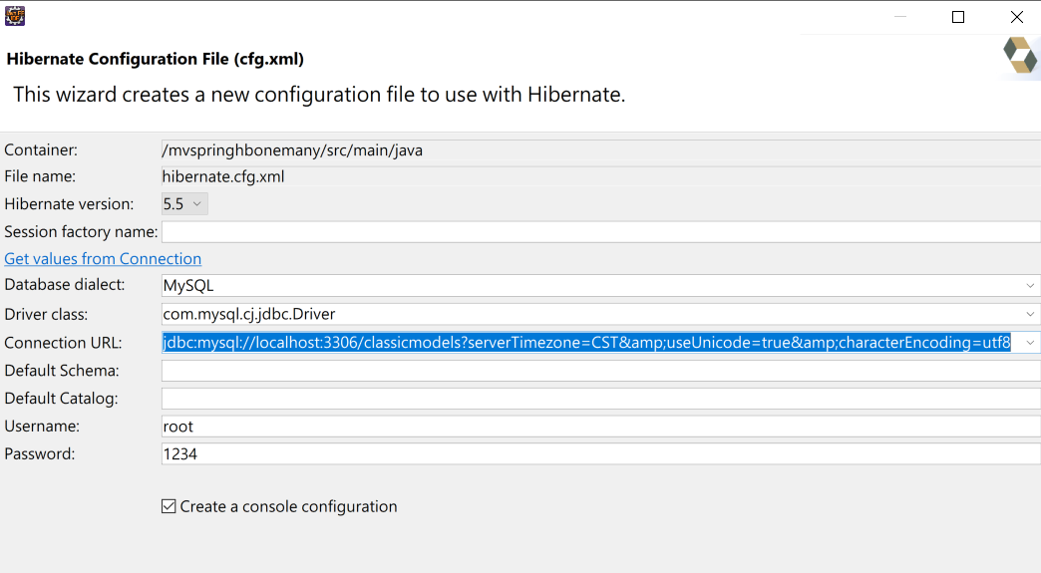

<?xml version="1.0" encoding="UTF-8"?>
<!DOCTYPE hibernate-configuration PUBLIC
"-//Hibernate/Hibernate Configuration DTD 3.0//EN"
"http://www.hibernate.org/dtd/hibernate-configuration-3.0.dtd">
<hibernate-configuration>
<session-factory>
<property name="hibernate.connection.driver_class">com.mysql.cj.jdbc.Driver</property>
<property name="hibernate.connection.password">1234</property>
<property name="hibernate.connection.url">jdbc:mysql://localhost:3306/classicmodels?serverTimezone=CST&amp;useUnicode=true&amp;characterEncoding=utf8</property>
<property name="hibernate.connection.username">root</property>
<property name="hibernate.dialect">org.hibernate.dialect.MySQLDialect</property>
</session-factory>
</hibernate-configuration>

- 資料庫需要有Suppliers Coffees 兩個1對多表格

建立表格
create table SUPPLIERS
(SUP_ID integer NOT NULL ,
SUP_NAME varchar(40) NOT NULL,
STREET varchar(40) NOT NULL,
CITY varchar(20) NOT NULL,
STATE char(2) NOT NULL,
ZIP char(5),
PRIMARY KEY (SUP_ID));

create table COFFEES
(COF_NAME varchar(32) NOT NULL,
SUP_ID int NOT NULL,
PRICE numeric(10,2) NOT NULL,
SALES integer NOT NULL,
TOTAL integer NOT NULL,
PRIMARY KEY (COF_NAME),
FOREIGN KEY (SUP_ID) REFERENCES SUPPLIERS (SUP_ID));

新增資料
insert into SUPPLIERS values(49, 'Superior Coffee', '1 Party Place', 'Mendocino', 'CA', '95460');
insert into SUPPLIERS values(101, 'Acme, Inc.', '99 Market Street', 'Groundsville', 'CA', '95199');
insert into SUPPLIERS values(150, 'The High Ground', '100 Coffee Lane', 'Meadows', 'CA', '93966');
insert into SUPPLIERS values(456, 'Restaurant Supplies, Inc.', '200 Magnolia Street', 'Meadows', 'CA', '93966');
insert into SUPPLIERS values(927, 'Professional Kitchen', '300 Daisy Avenue', 'Groundsville', 'CA', '95199');

insert into COFFEES values('Colombian', 101, 7.99, 0, 0);
insert into COFFEES values('French_Roast', 49, 8.99, 0, 0);
insert into COFFEES values('Espresso', 150, 9.99, 0, 0);
insert into COFFEES values('Colombian_Decaf', 101, 8.99, 0, 0);
insert into COFFEES values('French_Roast_Decaf', 049, 9.99, 0, 0);

- 建立Suppliers和 Coffees 表個 Entity Class 這裡我們會使用annotation 來設定java class和資料庫表格關聯
Coffee.java
package model;

import java.math.BigDecimal;

import javax.persistence.Column;
import javax.persistence.Entity;
import javax.persistence.Id;
import javax.persistence.JoinColumn;
import javax.persistence.ManyToOne;
import javax.persistence.Table;

@Entity
@Table(name="coffees")
public class Coffee implements java.io.Serializable {
@Id
@Column(name="COF_NAME")
private String cofName;
@ManyToOne
@JoinColumn(name="SUP_ID", referencedColumnName="SUP_ID")
private Supplier supplier;
private BigDecimal price;
private int sales;
private int total;

public Coffee() {
}

public Coffee(String cofName, Supplier supplier, BigDecimal price, int sales, int total) {
this.cofName = cofName;
this.supplier = supplier;
this.price = price;
this.sales = sales;
this.total = total;
}

public String getCofName() {
return this.cofName;
}

public void setCofName(String cofName) {
this.cofName = cofName;
}

public Supplier getSupplier() {
return this.supplier;
}

public void setSupplier(Supplier supplier) {
this.supplier = supplier;
}

public BigDecimal getPrice() {
return this.price;
}

public void setPrice(BigDecimal price) {
this.price = price;
}

public int getSales() {
return this.sales;
}

public void setSales(int sales) {
this.sales = sales;
}

public int getTotal() {
return this.total;
}

public void setTotal(int total) {
this.total = total;
}

}

Supplier.java

package model;

import java.util.*;

import javax.persistence.CascadeType;
import javax.persistence.Column;
import javax.persistence.Entity;
import javax.persistence.Id;
import javax.persistence.OneToMany;
import javax.persistence.Table;

@Entity
@Table(name="suppliers")
public class Supplier implements java.io.Serializable {

@Id
@Column(name="SUP_ID")
private int supId;
@Column(name="SUP_NAME")
private String supName;
private String street;
private String city;
private String state;
private String zip;
@OneToMany(mappedBy="supplier" , cascade = CascadeType.ALL)
private List<Coffee> coffeeses = new ArrayList<>();
//private Set<Coffees> coffeeses = new HashSet(0);

public Supplier() {
}

public Supplier(int supId, String supName, String street, String city, String state) {
this.supId = supId;
this.supName = supName;
this.street = street;
this.city = city;
this.state = state;
}

public Supplier(int supId, String supName, String street, String city, String state, String zip, List<Coffee> coffeeses) {
this.supId = supId;
this.supName = supName;
this.street = street;
this.city = city;
this.state = state;
this.zip = zip;
this.coffeeses = coffeeses;
}

public int getSupId() {
return this.supId;
}

public void setSupId(int supId) {
this.supId = supId;
}

public String getSupName() {
return this.supName;
}

public void setSupName(String supName) {
this.supName = supName;
}

public String getStreet() {
return this.street;
}

public void setStreet(String street) {
this.street = street;
}

public String getCity() {
return this.city;
}

public void setCity(String city) {
this.city = city;
}

public String getState() {
return this.state;
}

public void setState(String state) {
this.state = state;
}

public String getZip() {
return this.zip;
}

public void setZip(String zip) {
this.zip = zip;
}

public List<Coffee> getCoffeeses() {
return this.coffeeses;
}

public void setCoffeeses(List<Coffee> coffeeses) {
this.coffeeses = coffeeses;
}

}
- 加入hibernate.cfg.xml class->table mapping設定

<?xml version="1.0" encoding="UTF-8"?>
<!DOCTYPE hibernate-configuration PUBLIC "-//Hibernate/Hibernate Configuration DTD 3.0//EN"
"http://www.hibernate.org/dtd/hibernate-configuration-3.0.dtd">
<hibernate-configuration>
<session-factory>
<property name="hibernate.connection.driver_class">com.mysql.cj.jdbc.Driver</property>
<property name="hibernate.connection.password">1234</property>
<property name="hibernate.connection.url">jdbc:mysql://localhost:3306/classicmodels?serverTimezone=CST&amp;useUnicode=true&amp;characterEncoding=utf8</property>
<property name="hibernate.connection.username">root</property>
<property name="hibernate.dialect">org.hibernate.dialect.MySQLDialect</property>
<mapping class="model.Coffee"/>
<mapping class="model.Supplier"/>
</session-factory>
</hibernate-configuration>

- 實作控制器
package demo.controller;
import org.hibernate.Session;
import org.hibernate.SessionFactory;
import org.hibernate.Transaction;
import org.hibernate.boot.Metadata;
import org.hibernate.boot.MetadataSources;
import org.hibernate.boot.registry.StandardServiceRegistryBuilder;
import org.hibernate.service.ServiceRegistry;
import org.springframework.stereotype.Controller;
import org.springframework.ui.ModelMap;

import java.util.*;
import org.springframework.web.bind.annotation.RequestBody;
import org.springframework.web.bind.annotation.RequestMapping;
import org.springframework.web.bind.annotation.RequestMethod;
import org.springframework.web.servlet.ModelAndView;

import model.*;

@Controller
@RequestMapping("/")
public class SupplierCoffeeController {
List<Coffee> coffees = new ArrayList<>();

@RequestMapping(value="/supplier" ,method = RequestMethod.GET)
public String getSupplierView() {
return "supplier";
}
@RequestMapping(value = "/addSupplier", method = RequestMethod.POST )
public ModelAndView addSupplier(@RequestBody Supplier sup, ModelMap modelMap) {

modelMap.addAttribute("sups", sup);
return new ModelAndView("showSupplier");

}

@RequestMapping(value="/home" ,method = RequestMethod.GET)
public String getFirstView() {
return "home";
}
//@RequestBody利用Google JSON 接收前端傳送過來控制器由supplier接收
@RequestMapping(value = "/addCoffeeSupplier", method = RequestMethod.POST )
public ModelAndView addOrder(@RequestBody Supplier supplier, ModelMap modelMap) {
Supplier sup = supplier;
List<Coffee> cofs=sup.getCoffeeses();

for(int i=0;i<sup.getCoffeeses().size();i++) {
cofs.get(i).setSupplier(supplier);
}

modelMap.addAttribute("coffees", cofs);
modelMap.addAttribute("sups", sup);
save(supplier);
return new ModelAndView("showCoffee");
}
void save(Supplier supplier) {
sessionFactory = getSessionFactory();
Session session = sessionFactory.openSession();
System.out.println("Session created");
Transaction tx = session.beginTransaction();
session.saveOrUpdate(supplier);
tx.commit();
}
private static SessionFactory sessionFactory;
private SessionFactory buildSessionFactory() {
ServiceRegistry serviceRegistry = new StandardServiceRegistryBuilder().configure("hibernate.cfg.xml").build();
Metadata metadata = new MetadataSources(serviceRegistry).getMetadataBuilder().build();
SessionFactory sessionFactory = metadata.getSessionFactoryBuilder().build();
return sessionFactory;
}
public SessionFactory getSessionFactory() {
if (sessionFactory == null || sessionFactory.isClosed())
sessionFactory = buildSessionFactory();
return sessionFactory;
}
}
主畫面 home.jsp
<%@ page language="java" contentType="text/html; charset=UTF-8"
pageEncoding="UTF-8"%>
<!DOCTYPE html>
<html>
<head>
<meta charset="UTF-8">
<title>Supplier Coffee</title>
</head>
<body>
<style>
fieldset {
margin: 1.5em 0 0 0;
padding: 0;
border: 1px solid #CCC;
}

legend {
margin-left: 1em;
color: #009;
font-weight: bold;
}
</style>
<script
src="http://ajax.googleapis.com/ajax/libs/jquery/3.5.1/jquery.min.js"></script>
<fieldset>
<legend>Supplier Info</legend>
Supplier ID :<input type="text" id="supId" value="2" /><br />
Supplier Name :<input type="text" id="supName"
value="Bigs Coffee Inc.," /><br /> Street :<input type="text"
id="street" value="Kung Yuan 30" /><br /> City :<input type="text"
id="city" value="Taipei" /><br /> zip :<input type="text" id="zip"
value="100" /><br /> state :<input type="text" id="state"
value="TW" /><br />
</fieldset>
<p>
<fieldset>
<legend>Coffee Info</legend>
Coffee Name :<input type="text" id="cofName" value="Bigs Gold Brand" /><br />
Sale :<input type="text" id="sales" value="300" /><br /> total :<input
type="text" id="total" value="99" /><br /> price :<input
type="text" id="price" value="250" /><br />
<button id="send">Send</button>
</fieldset>
<div id="msg"></div>
<script>
function send() {
var cofObj=new Object();
cofObj.cofName=$("#cofName").val();
cofObj.sales=$("#sales").val();
cofObj.total=$("#total").val();
cofObj.price=$("#price").val();
cofObj.supplier=null;
var cofArry=[];
cofArry.push(cofObj);

var supobj=new Object();
supobj.supId=$("#supId").val();
supobj.supName=$("#supName").val();
supobj.street=$("#street").val();
supobj.city=$("#city").val();
supobj.state=$("#state").val();
supobj.zip=$("#zip").val();
supobj.coffeeses=cofArry;
var value=JSON.stringify(supobj);

$.ajax("addCoffeeSupplier",{
type:"post",
data: value,
contentType:"application/json", // 要送到server的資料型態
dataType:"html" , // 預期從server接收的資料型態
success: function (data, status) {
$("#msg").html(data);
},
error : function (data, status, errormsg) {
$("#msg").html(errormsg);
}
});

}
$(document).ready(function() {
$("#send").click(send);
});
</script>
</body>
</html>

showCoffee.jsp

<%@ page language="java" contentType="text/html; charset=UTF-8"
pageEncoding="UTF-8"%>
<%@taglib prefix="c" uri="http://java.sun.com/jsp/jstl/core"%>
<!DOCTYPE html>
<html>
<head>
<meta charset="UTF-8">
<title>Tables</title>
</head>
<body>
Supplier ID : ${sups.supId}<br>
Supplier Name:${sups.supName}
<table border="1" width="70%">
<tr>
<th>Coffee Name</th>
<th>Sales</th>
<th>Total</th>
<th>Price</th>

</tr>
<c:forEach var="current" items="${coffees}" >
<tr>
<td><c:out value="${current.cofName}" /></td>
<td><c:out value="${current.sales}" /></td>
<td><c:out value="${current.total}" /></td>
<td><c:out value="${current.price}" /></td>
</tr>
</c:forEach>
</table>

</body>
</html>
